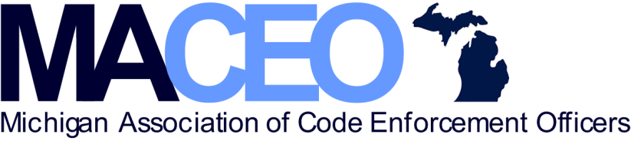

General Membership Meeting Agenda
Tuesday May 10, 2022
NOON
Ukrainian Cultural Center
26601 Ryan Road
Warren MI 48091

EDUCATIONAL SPEAKER: Phyllis Higman

CALL TO ORDER:

APPROVAL OF MINUTES: April 12, 2022

BUSINESS: Welcome new and returning board members

PRESIDENT’S REPORT: Entertainment Committee Volunteers

VICE PRESIDENT’S REPORT: June speaker announcement

BYLAWS COMMITEE: Jeff Kirkpatrick

TREASURERS REPORT: Fund and membership reports

ADJOURN

